Regular Prism
# Source: AI Source: Provided by: [Data Path: Persons Table -> ID Column: 1, Name_En Column: Motasem Essam] -> From: [ChatGPT] on [7/25/2026]
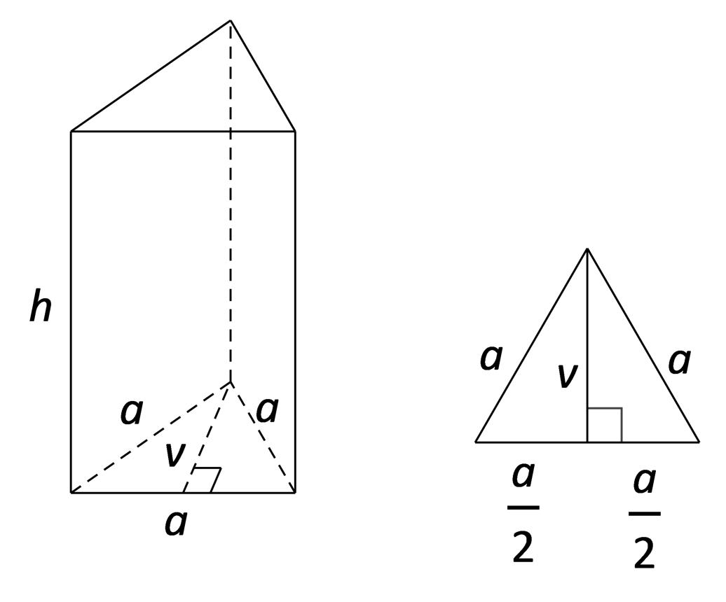
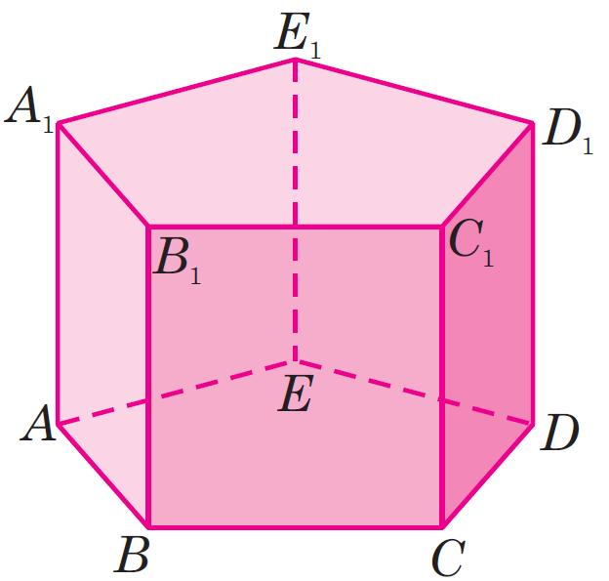
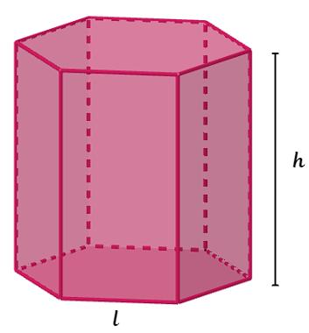

Definition
# Source: AI Source: Provided by: [Data Path: Persons Table -> ID Column: 1, Name_En Column: Motasem Essam] -> From: [ChatGPT] on [7/25/2026]
A regular prism is a prism whose bases are congruent regular polygons and whose lateral edges are perpendicular to the base planes. Therefore, a regular prism is a right prism with regular polygonal bases.
A regular polygon has all sides equal and all interior angles equal. Examples include an equilateral triangle, a square, and a regular pentagon.
Important distinction: A prism with regular polygonal bases but slanted lateral edges is an oblique prism, not a regular prism under the standard school-geometry definition.

Simple Definition
# Source: AI Source: Provided by: [Data Path: Persons Table -> ID Column: 1, Name_En Column: Motasem Essam] -> From: [ChatGPT] on [7/25/2026]
A regular prism is a three-dimensional solid with two identical, parallel regular polygon bases connected by rectangular side faces.

3. Classification
# Source: AI Source: Provided by: [Data Path: Persons Table -> ID Column: 1, Name_En Column: Motasem Essam] -> From: [ChatGPT] on [7/25/2026]
Solid Geometry
Three-Dimensional Solids
Polyhedra
Prisms
Regular Prism
Regular Triangular Prism
Regular Quadrilateral Prism
Square-based
Regular Pentagonal Prism
Regular Hexagonal Prism
Regular \(n\)-gonal Prism
General case for a regular polygon with \(n\) sides

Key Characteristics
# Source: AI Source: Provided by: [Data Path: Persons Table -> ID Column: 1, Name_En Column: Motasem Essam] -> From: [ChatGPT] on [7/25/2026]
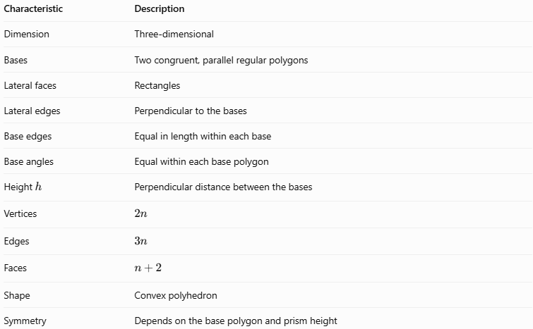
Characteristic | Description
Dimension | Three-dimensional
Bases | Two congruent, parallel regular polygons
Lateral faces | Rectangles
Lateral edges | Perpendicular to the bases
Base edges | Equal in length within each base
Base angles | Equal within each base polygon
Height $h$ | Perpendicular distance between the bases
Vertices | $$2n$$
Edges | $$3n$$
Faces | $$n+2$$
Shape | Convex polyhedron
Symmetry | Depends on the base polygon and prism height
Here, $n$ is the number of sides of each base polygon.

Geometric Representation
# Source: AI Source: Provided by: [Data Path: Persons Table -> ID Column: 1, Name_En Column: Motasem Essam] -> From: [ChatGPT] on [7/25/2026]
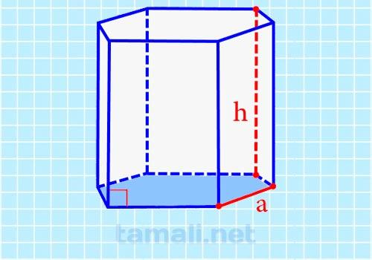
A regular prism has three main structural components:
- Base faces: The two congruent regular polygons at opposite ends.
- Lateral faces: The rectangular faces joining corresponding base edges.
- Lateral edges: The perpendicular segments joining corresponding vertices of the bases.
For example, a regular hexagonal prism has two regular hexagonal bases and six rectangular lateral faces.
Examples by base polygon
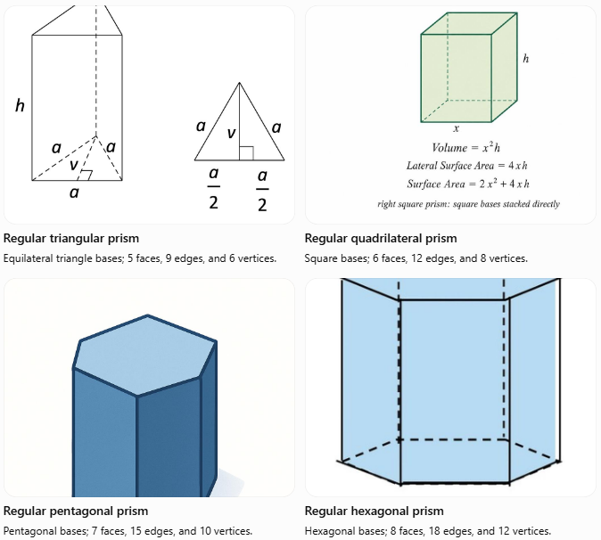
Regular triangular prism
Equilateral triangle bases; 5 faces, 9 edges, and 6 vertices.
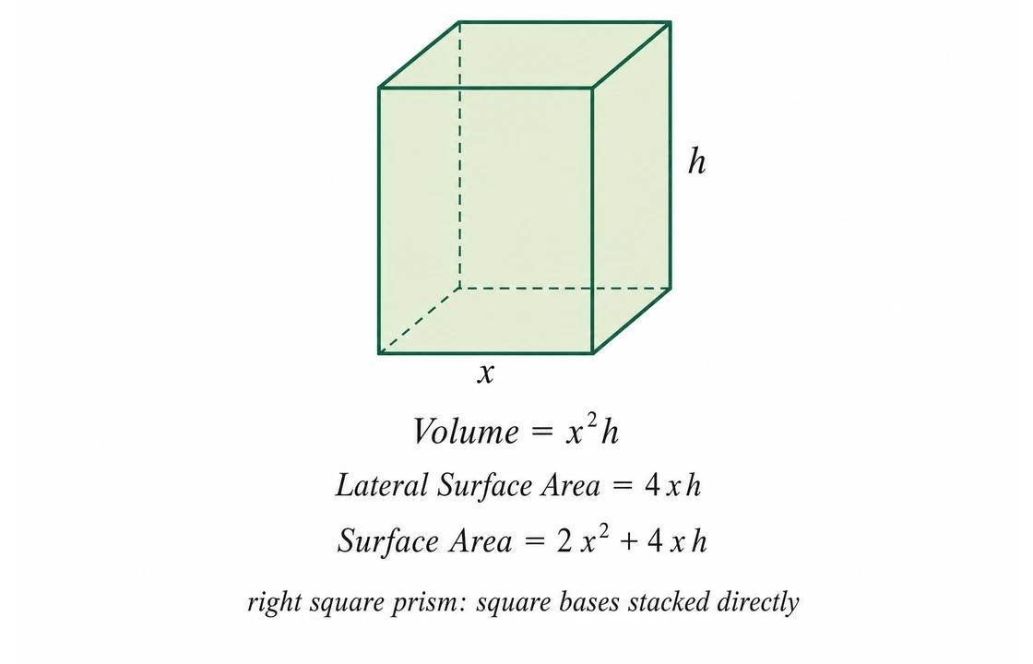
Regular quadrilateral prism
Square bases; 6 faces, 12 edges, and 8 vertices.

Regular pentagonal prism
Pentagonal bases; 7 faces, 15 edges, and 10 vertices.
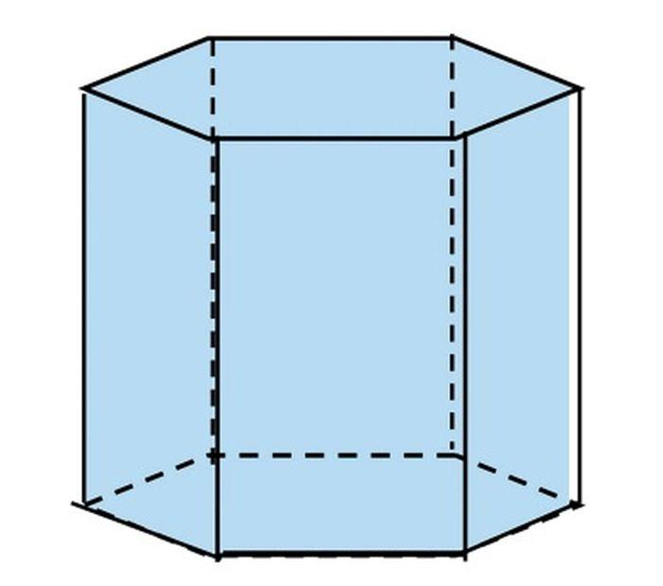
Regular hexagonal prism
Hexagonal bases; 8 faces, 18 edges, and 12 vertices.

Mathematical Representations and Formulas
Let:
- $n$ = number of sides of each base.
- $a$ = side length of the regular polygonal base.
- $h$ = perpendicular height of the prism.
- $P$ = perimeter of the base.
- $B$ = area of one base.

Number of Faces, Edges, and Vertices
# Source: AI Source: Provided by: [Data Path: Persons Table -> ID Column: 1, Name_En Column: Motasem Essam] -> From: [ChatGPT] on [7/25/2026]

Quantity | Formula
Faces | $$F=n+2$$
Edges | $$E=3n$$
Vertices | $$V_{e}=2n$$
Base edges | $2n$ in total
Lateral edges | $$n$$
These formulas satisfy Euler's formula for convex polyhedra:
$$V_{e}-E+F=2$$
Substituting the prism formulas:
$$2n-3n+\left(n+2\right)=2$$

Perimeter of the Base
# Source: AI Source: Provided by: [Data Path: Persons Table -> ID Column: 1, Name_En Column: Motasem Essam] -> From: [ChatGPT] on [7/25/2026]
Since the base is a regular polygon with $n$ equal sides:
$$\boxed{P=na}$$

Area of the Base
# Source: AI Source: Provided by: [Data Path: Persons Table -> ID Column: 1, Name_En Column: Motasem Essam] -> From: [ChatGPT] on [7/25/2026]
For a regular polygon with side length $a$ and $n$ sides:
$$\boxed{B=\frac{na^{2}}{4\tan\left(π/n\right)}}$$
Alternatively, using the base apothem $q$:
$$\boxed{B=\frac{12}{P}q}$$
The apothem is the perpendicular distance from the center of the regular polygon to one of its sides.

Volume
# Source: AI Source: Provided by: [Data Path: Persons Table -> ID Column: 1, Name_En Column: Motasem Essam] -> From: [ChatGPT] on [7/25/2026]
The volume of any prism equals its base area multiplied by its perpendicular height:
$$\boxed{V=Bh}$$
For a regular prism:
$$\boxed{V=\frac{na^{2}h}{4\tan\left(π/n\right)}}$$

6.5 Lateral Surface Area
# Source: AI Source: Provided by: [Data Path: Persons Table -> ID Column: 1, Name_En Column: Motasem Essam] -> From: [ChatGPT] on [7/25/2026]
Because a regular prism is a right prism, its lateral faces are rectangles. Their combined area is:
$$\boxed{A_{L}=Ph}$$
Since $P=na$:
$$\boxed{A_{L}=nah}$$

6.6 Total Surface Area
# Source: AI Source: Provided by: [Data Path: Persons Table -> ID Column: 1, Name_En Column: Motasem Essam] -> From: [ChatGPT] on [7/25/2026]
A closed prism has two bases and its lateral faces:
$$A_{T}=2B+A_{L}$$
Therefore:
$$\boxed{A_{T}=2B+Ph}$$
Or, using the regular polygon formula:
$$\boxed{A_{T}=\frac{na^{2}}{2\tan\left(π/n\right)}+nah}$$

Worked Examples
# Source: AI Source: Provided by: [Data Path: Persons Table -> ID Column: 1, Name_En Column: Motasem Essam] -> From: [ChatGPT] on [7/25/2026]
Example 1: Regular Triangular Prism
A regular triangular prism has an equilateral triangular base with side length $a=4\text{ cm}$ and height $h=10\text{ cm}$. Find its volume and total surface area.
Step 1: Calculate the base area.
The area of an equilateral triangle is:
$$B=\frac{\sqrt{3}}{4}a^{2}$$
$$B=\frac{\sqrt{3}}{4}{\left(4\right)}^{2}=4\sqrt{3}$$
Step 2: Calculate the volume.
$$V=Bh=\left(4\sqrt{3}\right)\left(10\right)$$
$$\boxed{V=40\sqrt{3}≈69.28{\text{ cm}}^{3}}$$
Step 3: Calculate the lateral surface area.
The base perimeter is $P=3\left(4\right)=12\text{ cm}$.
$$A_{L}=Ph=12\left(10\right)=120{\text{ cm}}^{2}$$
Step 4: Calculate the total surface area.
$$A_{T}=2B+A_{L}$$
$$A_{T}=8\sqrt{3}+120$$
$$\boxed{A_{T}≈133.86{\text{ cm}}^{2}}$$
Example 2: Regular Hexagonal Prism
A regular hexagonal prism has side length $a=3\text{ cm}$ and height $h=8\text{ cm}$. Calculate its volume.
The area of a regular hexagon is:
$$B=\frac{3\sqrt{3}}{2}a^{2}$$
Substitute $a=3$:
$$B=\frac{3\sqrt{3}}{2}\left(9\right)=\frac{27\sqrt{3}}{2}$$
Now calculate the volume:
$$V=Bh$$
$$V=\frac{27\sqrt{3}}{2}\left(8\right)$$
$$\boxed{V=108\sqrt{3}≈187.06{\text{ cm}}^{3}}$$
Example 3: Count Faces, Edges, and Vertices
A regular pentagonal prism has $n=5$.
- Faces: $F=5+2=\boxed{7}$
- Edges: $E=3\left(5\right)=\boxed{15}$
- Vertices: $V_{e}=2\left(5\right)=\boxed{10}$
Check Euler's formula:
$$10-15+7=2$$
Therefore, the counts satisfy Euler's formula.

Comparison with Related Types of Prisms
# Source: AI Source: Provided by: [Data Path: Persons Table -> ID Column: 1, Name_En Column: Motasem Essam] -> From: [ChatGPT] on [7/25/2026]
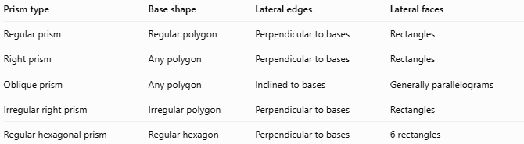
Prism type | Base shape | Lateral edges | Lateral faces
Regular prism | Regular polygon | Perpendicular to bases | Rectangles
Right prism | Any polygon | Perpendicular to bases | Rectangles
Oblique prism | Any polygon | Inclined to bases | Generally parallelograms
Irregular right prism | Irregular polygon | Perpendicular to bases | Rectangles
Regular hexagonal prism | Regular hexagon | Perpendicular to bases | 6 rectangles
Key distinction: Every regular prism is a right prism, but not every right prism is a regular prism. A right prism with irregular polygonal bases does not qualify as a regular prism.

Applications of Regular Prisms
# Source: AI Source: Provided by: [Data Path: Persons Table -> ID Column: 1, Name_En Column: Motasem Essam] -> From: [ChatGPT] on [7/25/2026]

Product design
Hexagonal pencils approximate regular hexagonal prisms, making them easier to grip and less likely to roll away.
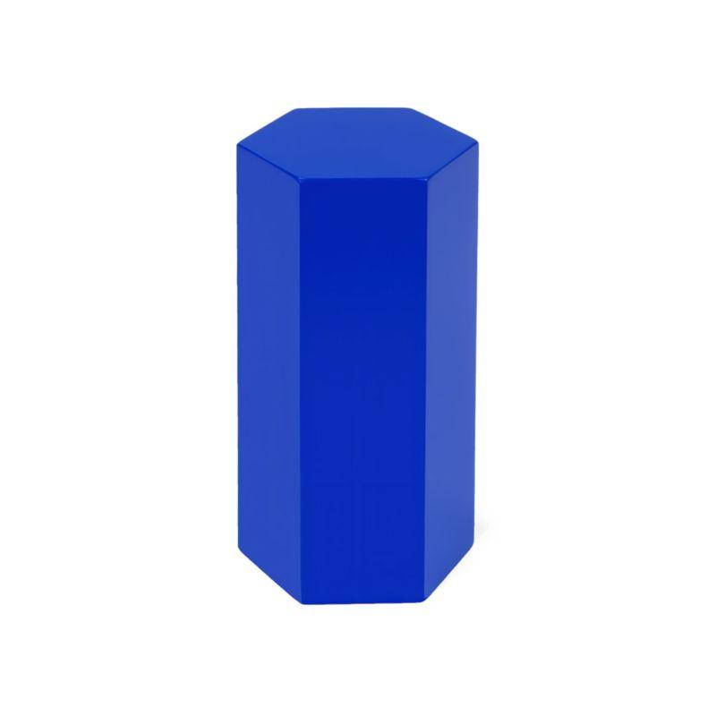
Architecture
Polygonal columns and structural elements can use prism-like shapes for design and construction.
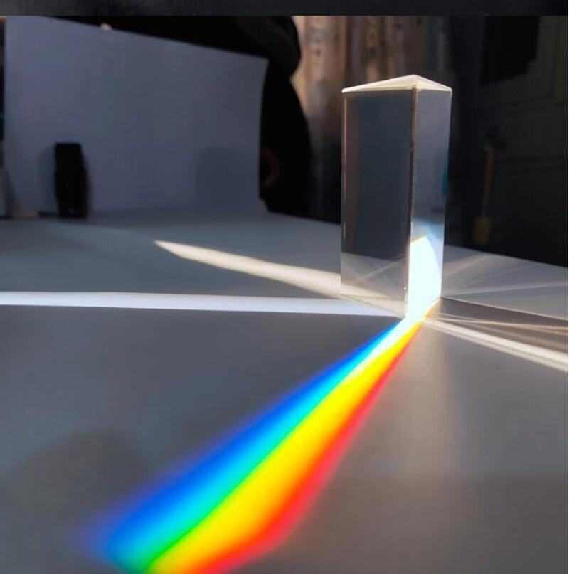
Optics and science
Triangular prisms are used to refract and separate light, although optical prisms may have different geometric proportions and are not necessarily regular prisms.
Engineering and mathematics
Regular prisms help with volume calculations, surface-area calculations, geometric modeling, and structural design.

Key Points
# Source: AI Source: Provided by: [Data Path: Persons Table -> ID Column: 1, Name_En Column: Motasem Essam] -> From: [ChatGPT] on [7/25/2026]
- A regular prism has two congruent, parallel regular polygon bases.
- Its lateral edges are perpendicular to the bases.
- All lateral faces are rectangles.
- For an $n$-gonal prism, $F=n+2$, $E=3n$, and $V_{e}=2n$.
- Its volume is $V=Bh$.
- Its lateral surface area is $A_{L}=Ph$.
- Its total surface area is $A_{T}=2B+Ph$.
- A regular prism is a special type of right prism.

Conclusion
# Source: AI Source: Provided by: [Data Path: Persons Table -> ID Column: 1, Name_En Column: Motasem Essam] -> From: [ChatGPT] on [7/25/2026]
A regular prism is a convex polyhedron with two identical regular polygon bases connected by rectangular lateral faces. Its regular base determines its polygonal type, while its height determines its length. The general formulas make it straightforward to calculate its volume, surface area, faces, edges, and vertices.

